Challenge-3

Bash Script to create repo in github.

* To create a repo, first we need to generate the access token in github(it grants access to your GitHub account)
* To generate we follow:

1. log into your GitHub account.
2. Settings
3. Developer settings
4. Generate access token(classic)
5. Copy the access token

* Create a bash script

### 

### 2. Defining Variables

GITHUB_USERNAME="Krishnaveni0321"

REPO_NAME=$1

REPO_DESCRIPTION=$2

PRIVATE_REPO=${3:-false} # Defaults to public repo if not specified

* GITHUB_USERNAME: Sets the GitHub username.
* REPO_NAME: Takes the first argument ($1) from the command line as the repository name.
* REPO_DESCRIPTION: Takes the second argument ($2) as the repository description.
* PRIVATE_REPO: Takes an optional third argument ($3) to specify whether the repository should be private. If not specified, it defaults to false (public).

### Checking if Repository Name is Provided

if [ -z "$REPO_NAME" ]; then

echo "Error: No repository name provided."

echo "Usage: ./create_github_repo.sh <repo_name> [repo_description] [private]"

exit 1

fi

* This checks if REPO_NAME is empty (-z "$REPO_NAME"), meaning no repository name was provided.
* If empty, the script displays an error message, usage instructions, and then exits with a non-zero status (exit 1), indicating failure.

### Sending the API Request to Create the Repository

response=$(curl -s -w "%{http_code}" -o temp_response.json \

-H "Authorization: token $GITHUB_TOKEN" \

-d "{\"name\": \"$REPO_NAME\", \"description\": \"$REPO_DESCRIPTION\", \"private\": $PRIVATE_REPO}" \

https://api.github.com/user/repos)

* curl is used to make an HTTP POST request to the GitHub API to create the repository.
* -s: Runs curl silently, suppressing progress output.
* -w "%{http_code}": Outputs only the HTTP status code (like 201 for success).
* -o temp_response.json: Saves the JSON response (body content) to a temporary file named temp_response.json for error checking.
* -H "Authorization: token $GITHUB_TOKEN": Sets an HTTP header for authorization using the GitHub token.
* -d "{...}": Sends the data in JSON format, with fields name, description, and private set to the specified variables.
* The URL (https://api.github.com/user/repos) is the endpoint for creating a repository.
* Giving permissions to execute the code

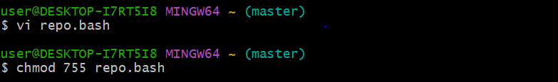

* Executing the script

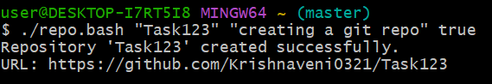

* We can check theoutput in github that a new repo has been created

